

AI Assisted Problem Solving Using Python

AcademicYear:2025-2026

Assignment Type: Lab
Assig_No. 7

Submitted by:
Name: NUKALA MEGHANA SRI
Enroll No.2503b05113
Course: M-Tech CSE

Submitted to:
Name: Venkataramana Veeramsetty
Title: Course Instructor

Date: 04 Nov 2025

Task Description#1
- Paste a function with a missing colon (add(a, b)), and let AI fix the syntax error.
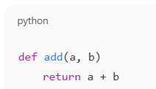

Expected Output#1
- Corrected function with syntax fix
Prompt:
- Fix the syntax error in this Python code:
Generated Code:

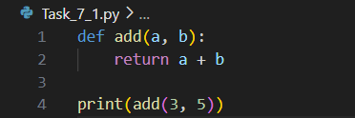

Explanation:
- AI detected that the function header was missing a colon (:) after the parameter list.
- It corrected the syntax and provided a proper structure.
- The corrected function now executes successfully and returns the sum.
Example Output:

Task Description#2 (Loops)
- Identify and fix a logic error in a loop that causes infinite iteration.


Expected Output#2
- AI fixes increment/decrement error

Prompt:
- The following code runs infinitely. Identify and fix the logic error.
Generated Code:

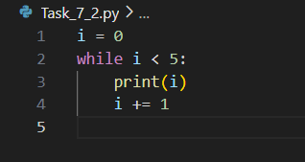

Explanation:
- The original loop had no increment statement, leading to an infinite loop.
- AI added i += 1 to update the loop variable.
- Now the program executes five times and terminates correctly.
Example Output:

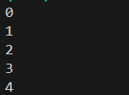

Task Description#3
- Debug a runtime error caused by division by zero. Let AI insert try-except.


Expected Output#3
- Corrected function with safe error handling
Prompt:
- Fix the runtime error in the following code that crashes due to division by zero.
Generated Code:
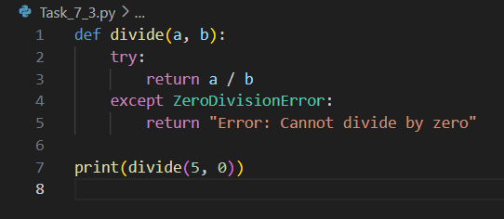
Explanation:
- AI recognized that dividing by zero causes a runtime exception.
- It added a try-except block to handle ZeroDivisionError, preventing the program from
- crashing and providing a meaningful message.
Example Output:

Task Description#4
- Provide a faulty class definition (missing self in parameters). Let AI fix it


Expected Output#4
- Correct __init__() method and explanation

Prompt:
- Fix the missing self parameter in the following Python class:
Generated Code:

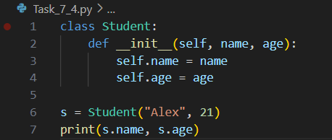

Explanation:
- The original code missed the self parameter in __init__().
AI added self as the first argument in the constructor and correctly assigned instance
- variables.
- Now the class creates objects successfully.
Example Output:

Task Description#5
- Access an invalid list index and use AI to resolve the Index Error.


Expected Output#5
- AI suggests checking length or using safe access logic
Prompt:
- Fix the following Python code that raises an IndexError.
Generated Code:

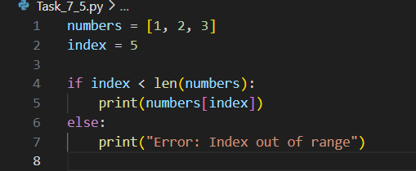

Explanation:
- AI added a length check before accessing the list element.
- This prevents IndexError and provides a clear error message if the index is invalid.
Example Output:

